To acieve concide code.(code wil less LOC)
Enabling Functional Programming

1. Lambda Expressions
2. Functional Interface
3. Default Methods and static Methods.
4. Predefined Functional Interface
Predicate
Function
Consumer
Supplier
etc
5. Doubli colon Operator(::)
Method Reference
Constructor Reference
6. Streams
7. Date and Time API
8 Optional class
9 Narshon JavaScript
etc

Function<Integer, Integer> f = i -> i * i;
System.out.println("the square of 5 is "+f.apply(5));

Predicate<Integer> p = i -> i%2 == 0 ;
System.out.println(p.test(4));

1. Lambda Expression: It is anonymous Function (nameless Function, no return type, without modifier )
main objective of lambda Expression --> to bring benefits of Functional Programming in java.

ex:
old approach for method:
public void add(int a , int b)
{
System.out.println(a+b);
}

lambda Expression:

1. (int a,int b) -> System.out.println(a+b);
2. (a,b) -> System.out.println(a+b);
3. (a,b) -> { System.out.println(a+b) };

Functional Interface :

Runnable ---> run()
Comparator ---> compareTo()
Comparable --> compare()
ActionListener --> actionPerformed()
Callable ---> call()
The functions ehich contain single abstract method is called functional interface.

@FunctionalInterface ---> this annotation is Optional annotation that we can give when we are writing the FunctionalInterface
this annotation will validate our functional interface whether it is fulfilling the functional interface requirements are not.

interface Interf
{
public void add(int a ,int b);
}

class Test()
{
public static void main(String[] args)
{
Interf i = (int a ,int b) -> System.out.println(a+b);
i.add(5,5);
}
}

****** Lambda Expressions are applicable only for Functional Interface.

Lambda Expressions with MultiThreading

class Test{

public static void main(String[] args)
{
Runnable r = () ->{

for(int i=0;i<5;i++)
{
System.out.println("child thread"+i);
}
};
Thread t =new Thread(r);
t.start();
for(int i=0;i<5;i++)
{
System.out.println("main thread"+i);
}

}
}

Lambda Expressions with collections:

Lambda Expressions with Comparator:

******************************* old approach *************************************

class MyComparator implements Comparator<Integer>
{
@override
public int compare(int I1, int I2)
{
if(I1<T2)
{
return -1;
}
if(I1>T2)
{
return +1;
}
else
{
return 0;
}
/// if(I1>i2)? return -1 :(I1<I2)? return +1 : return 0;

}
}

*************************************new approach ***********************************
class Test()
{
public static void main(String[] args)
{
ArrayList<Integer> list = new ArrayList<Integer>();
list.add(6);
list.add(20);
list.add(11);
list.add(3);
list.add(10);

Comparator<Integer> c = if(I1>i2)? return -1 :(I1<I2)? return +1 : return 0;
collections.sort(list,c);
System.out.println(list);
}

}

Lambda Expressions with Comparable:
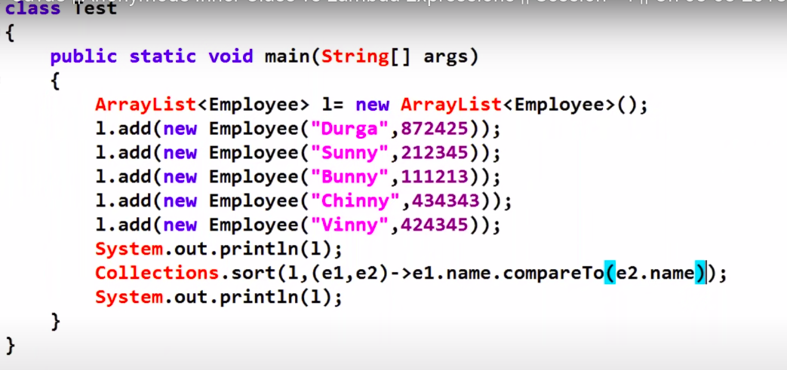
Anonymous inner classes:
Anonymous inner classes are used for instant usage.
Anonymous inner classes != lambda expression

If anonymous inner class implements an interface that contains single abstract method then only we can replace that anonymous inner class with lambda expression.
Anonymous inner classes can extend an abstract method.
Lambda expression can implement an interface which contain a single abstract method.
All Anonymous inner classes cannot contain lambda expression.
------------55555----------------
Default methods in interface:

Default methods are optional for the implementation classes.The implementation classes can use the existing implementation or can override the default method.
why multiple inheritance is not supported in java?
Interface supports static methods because static methods not required object.These static methods contain implementation.

Methods a Subclass Cannot Override
Also, a subclass cannot override methods that are declared static in the superclass. In other words, a subclass cannot override a class method.

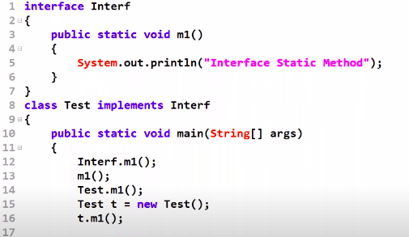
Main method can be declared in interface.
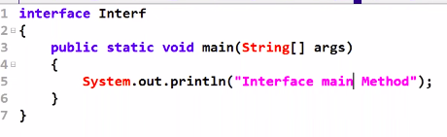

----------------666666666---------
Functional Interfaces:
Predicate<T> :
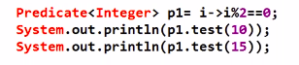

String

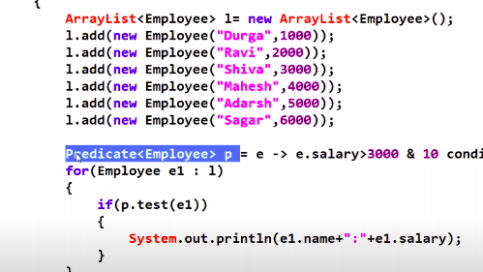
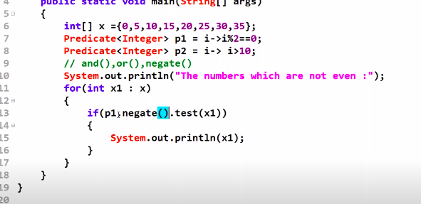
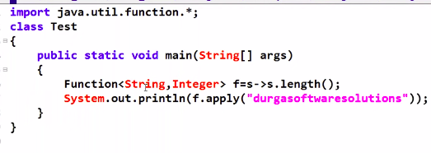
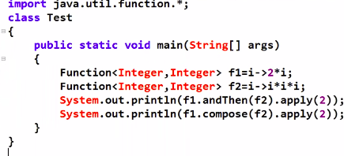
Predicate , Function and Consumer

take some input and perform some condiional check and return boolean ---->predicate
take some input and perform some operation and returns some value --->Functional
chaining: andThen(), compose(), negate, and(),or()
Accept some input and perform required operation and not required to return anything ---->Consumer

Consumer Chaining:

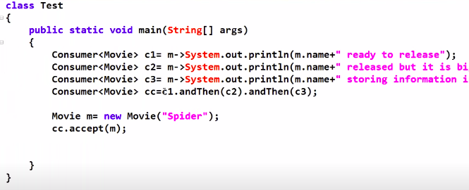
Supplier:

Just it will supply required objects and it wont take any input ----> Supplier
interface Supplier<R>
{
public R get();
}

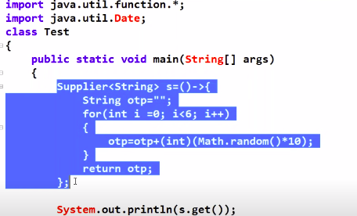

Normal predicate can take only one input arguement and perform some conditional check Sometimes our programming requirement is to we have to take 2 input arguements and performs some conditional check, for this requirement we should go for 2 input arguements.

1. Whether the given int is even or not Predicate

check the sum of 2 given nummbers is even or not?
In the above case we need to take 2 arguements as input but predicate and function supports only one arguements as input.
In this case we need to go for BiFunction or BiPredicate

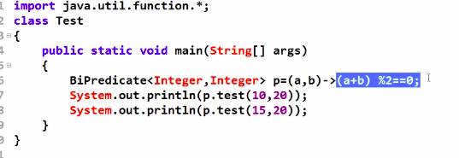
BiFunction:
Takes 2 arguements as input and gives single output.

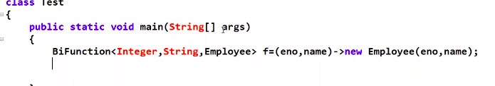
BiConsumer:

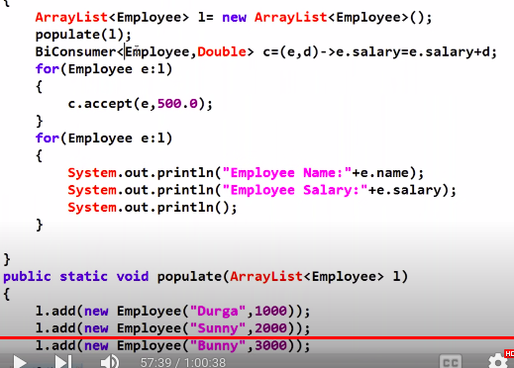
Method Reference:

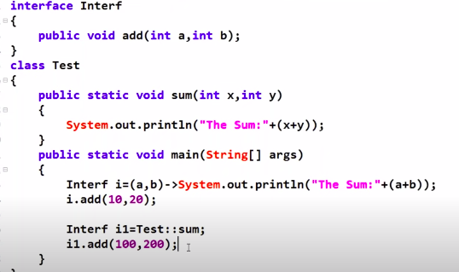
Constructor reference:

